

*Department of Software Engineering*

**DOCUMENTATION ON**

**Address Book Management System**

**(Class Project)**

Course Code: SWE 331

Course Title: Object Oriented Software Development

Date: 06/12/2017

**Submitted By:**

Md Roknuzzaman

ID: 151-35-906

**Submitted To:**

Md. Alamgir Kabir

Lecturer

Dept. of SWE

**Table of Contents**

**Chapter 1** 3

**1** **Introduction** 3

**1.1About the system:** 3

**1.2 Purpose:** 3

**1.3 Scope:** 3

**1.4 Vision:** 4

**1.5 Why the system needed:** 4

**1.6 Proposed solution:** 4

**Chapter 2** 5

**2 System analysis:** 5

**2.1 Actor goal list:** 5

**2.2 Use case model:** 5

**2.3 Use case description:** 6

**2.4 Use case description table:** 6

**2.5 System sequence diagram:** 8

**2.6 Domain model:** 10

**2.7 Activity diagram:** 11

**Chapter 3** 12

**3 System design:** 12

**3.1 Sequence diagram:** 12

**3.2 Class diagram:** 13

**3.3 ER diagram:** 15

**Chapter 4** 16

**Implementation:** 16

**4.1 References:** 16

**4.2 Project link** 16

**List of Table**

**Table 1: Use Case Description of Create Address Book** 6

**Table 2: Use Case Description of Manage Person** 7

**Table 3: Use Case Description of Search People** 7

**List of Figures**

**Figure 1: Use Case Model** 5

**Figure 2: System Sequence Diagram of Create Address Book** 8

**Figure 3: System Sequence Diagram of Input details** 9

**Figure 4: System Sequence Diagram of Search** 10

**Figure 5: Domain Model** 10

**Figure 6: Activity Diagram** 11

**Figure 7: Sequence Diagram of Create Address Book** 12

**Figure 8: Sequence Diagram of Add/Edit Person details** 12

**Figure 9: Sequence Diagram of Search** 13

**Figure 10: Class Diagram** 14

**Figure 11: ER Diagram** 15

# **Chapter 1**

# **Introduction**

## **1.1About the system:**

Online address book project is implemented in PHP platform. Main aim of this project is to develop a online web application for storing users first and last names, address, city, state, zip, and phone number. Users can view this application from anywhere if user has internet facility and valid credentials. In real life there are certain times where we loose our contacts from mobile or system in that time this application will be helpful. Users are provided with a simple user friendly graphical user interface for updating contact details to database.  
Users need to register with application by filling online registration form and get unique user name and password. User can log into the system and add contacts to list and user can search for available contacts in the list, add and delete contacts.  
In existing system there are no online applications which can store contacts on internet. Normally contacts are stored in mobile or phone books which are not an efficient method to mange contacts. In this method there are no alternative methods to store data.  
In present system users can store address to online address book which can be viewed from anywhere from the world and there is no chance of losing contacts.

## **1.2 Purpose:**

The main purpose of building this project is to make a user friendly address book system. . In real life there are certain times where we loose our contacts from mobile or system in that time this application will be helpful. An online address book typically enables users to create their own web page (or profile page) which is then indexed by search engines like Google and Yahoo. This in turn enables users to be found by other people via a search of their name and then contacted via their web page containing their personal information. Ability to find people registered with online address books via search engine searches usually varies according to the commonness of the name and the amount of results for the name. Typically users of such systems can synchronize their contact details with other users that they know to ensure that their contact information is kept up to date. And we can also print the address list in mailing lebel format which will help us a lot.

## **1.3 Scope:**

An online address book typically enables users to create their own web page (or profile page) which is then indexed by search engines like Google and Yahoo. This in turn enables users to be found by other people via a search of their name and then contacted via their web page containing their personal information. Ability to find people registered with online address books via search engine searches usually varies according to the commonness of the name and the amount of results for the name. And the online address book could be the next social media.

## **1.4 Vision:**

The vision of this project is to maintain the information of user in a web based storage which he can access through the internet. And the main vision is to maintain those information.

## **1.5 Why the system needed:**

In real life there are certain times where we loose our contacts from mobile or system in that time this application will be helpful. Users are provided with a simple user friendly graphical user interface for updating contact details to database.

## **1.6 Proposed solution:**

The proposed solution is to build a PHP based online system that able to add a new person to an address book, to edit existing information about a person (except the person's name), and to delete a person. It must be possible to sort the entries in the address book alphabetically by last name (with ties broken by first name if necessary), or by ZIP code (with ties broken by name if necessary). It must be possible to print out all the entries in the address book in "mailing label" format.

It must be possible to create a new address book, to open a disk file containing an existing address book to close an address book, and to save an address book to a disk file, using standard New, Open, Close, Save and Save As ... File menu options. The program's File menu will also have a Quit option to allow closing all open address books and terminating the program.

# **Chapter 2**

# **2 System analysis:**

## **2.1 Actor goal list:**

|  |  |
| --- | --- |
| Actor | Goal |
| User | * Create a address book * Input the details of a person he wanted * Manage the person detail * Search the person detail * Print the person detail |

## **2.2 Use case model:**

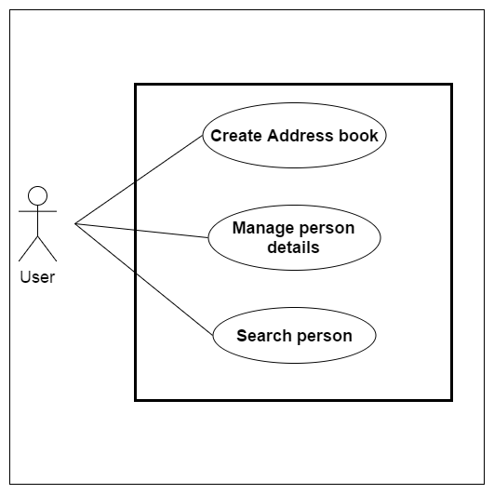

**Figure 1: Use Case Model**

## **2.3 Use case description:**

1. **Use case name:** Create address book

**Description:**

In this use case the user will create a new address book in which he can able to save or implement some information of a person.

He has to press the button create new and give a name to this address book.

1. **Use case name:** Manage person detail

**Description:**

In this use case the user can add a new persons detail information to the system. And he also be able to delete or edit those information whenever he wanted to do.

1. **Use case name:** Search person detail

**Description:**

In this use case the user is able to search a person’s detail information by the first name of the person or by the zip code of the person where he lived on.

## **2.4 Use case description table:**

**Table 1: Use Case Description of Create Address Book**

|  |  |  |
| --- | --- | --- |
| Use Case Name: | Create a address book | |
| Scenario: | Create a address book with detail | |
| Brief Description: | A address book will contain various person’s detail information | |
| Actors: | User | |
| Stakeholders: | The user who wants to create a address book | |
| Precondition: | A user must exist, Must give a name. | |
| Postcondition: | Must save the address book before exit | |
| Flow of Events: | Actor | System |
| 1. User will give a name of address book. 2. User initiate the creation of address book. 3. Save the address book. | * 1. Create new address book   3.1 save the information in computer. |
| Exception Conditions: | 3.1 If the user forget to save the address book he could lose the information. | |

**Table 2: Use Case Description of Manage Person**

|  |  |  |
| --- | --- | --- |
| Use Case Name: | Manage person detail | |
| Scenario: | Edit a person’s information | |
| Brief Description: | User can update or edit the information of a person if needed. | |
| Actors: | User | |
| Stakeholders: | The user who wants to edit a person’s information under address book | |
| Precondition: | Must existing information. | |
| Postcondition: | Must save the update person detail. | |
| Flow of Events: | Actor | System |
| 1. Must have previous person information. 2. Must save the update details before exit. | * 1. system will replace the new information with the older one’s. |
| Exception Conditions: | 2.1 If the user forget to save the address book he could loose the information. | |

**Table 3: Use Case Description of Search People**

|  |  |  |
| --- | --- | --- |
| Use Case Name: | Search person | |
| Scenario: | Search a person’s information | |
| Brief Description: | Search a person according to first name or zip code | |
| Actors: | User | |
| Stakeholders: | The user who wants to find a person’s information under address book | |
| Precondition: | Must input person’s first name or zip code | |
| Postcondition: |  | |
| Flow of Events: | Actor | System |
| 1. must input first name to search a person. | * 1. the system will find out the related information according to the search input |
| Exception Conditions: | 1.1.if the user doesn’t input a valid input the system will show no result. | |

## **2.5 System sequence diagram:**

Create address book: Main flow

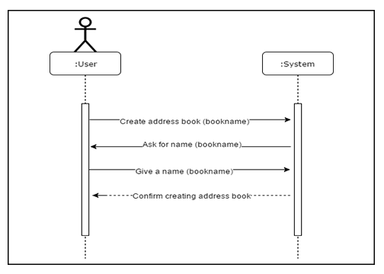

**Figure 2: System Sequence Diagram of Create Address Book**

Manage person details : Main flow

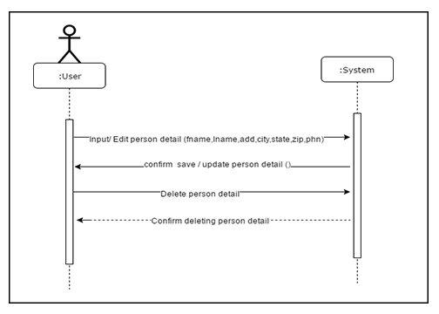

**Figure 3: System Sequence Diagram of Input details**

Search person detail’s : Main flow

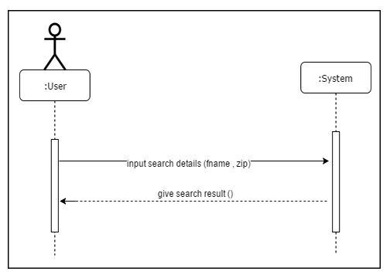

**Figure 4: System Sequence Diagram of Search**

## **2.6 Domain model:**

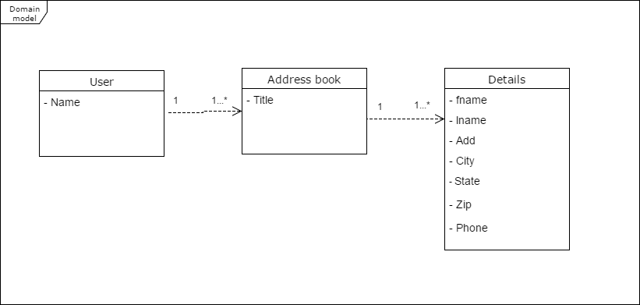

**Figure 5: Domain Model**

## **2.7 Activity diagram:**

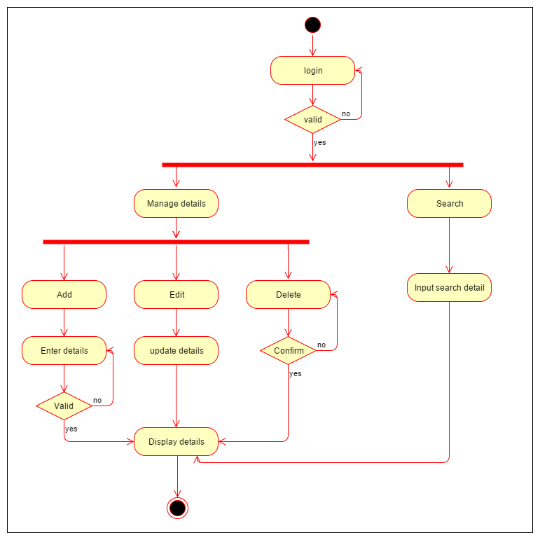

**Figure 6: Activity Diagram**

# **Chapter 3**

# **3 System design:**

**3.1 Sequence diagram:**

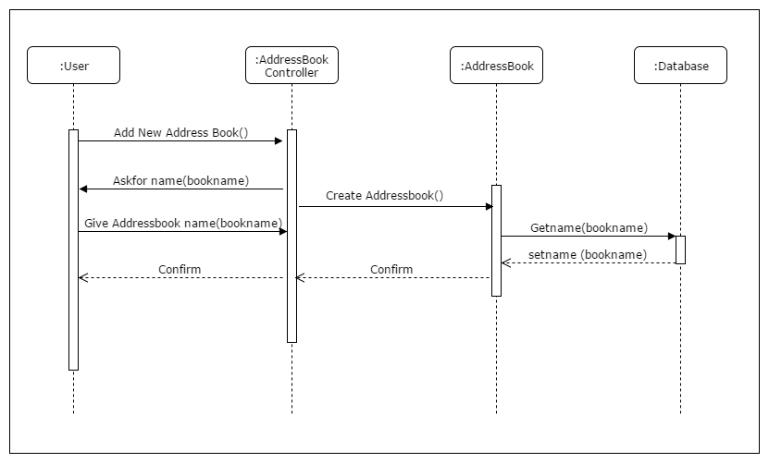

**Figure 7: Sequence Diagram of Create Address Book**

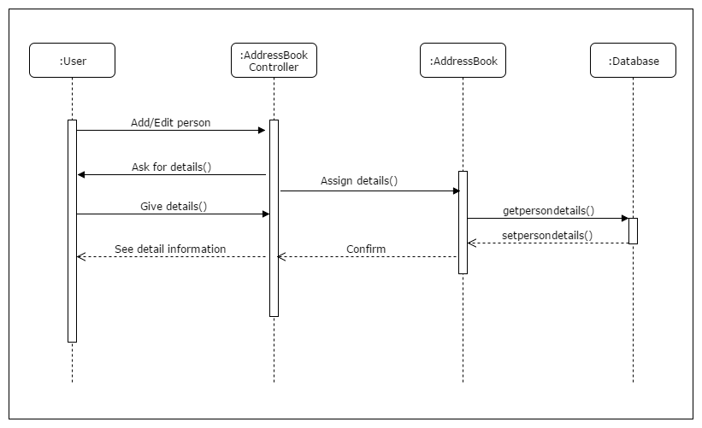

**Figure 8: Sequence Diagram of Add/Edit Person details**

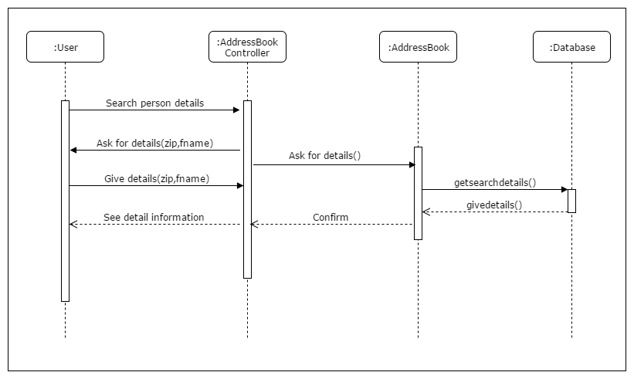

**Figure 9: Sequence Diagram of Search**

## **3.2 Class diagram:**

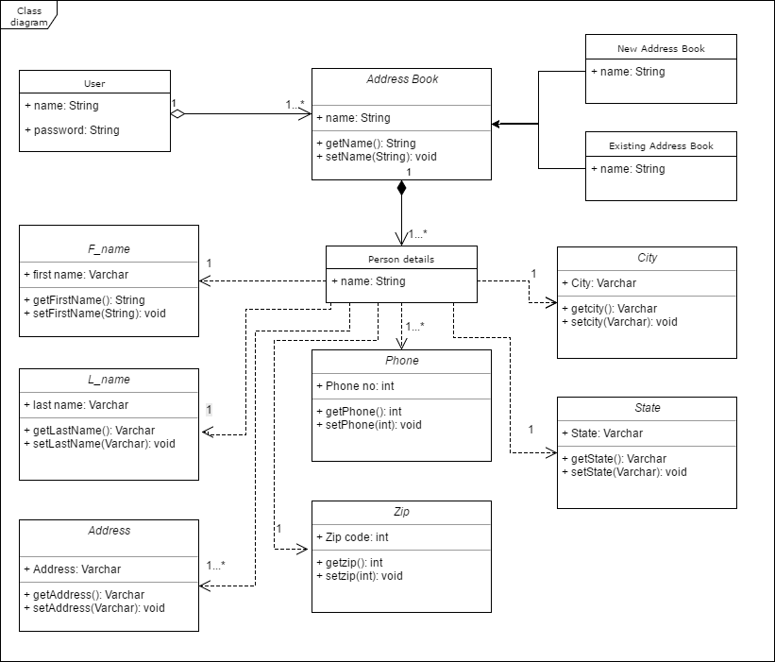

**Figure 10: Class Diagram**

## **3.3 ER diagram:**

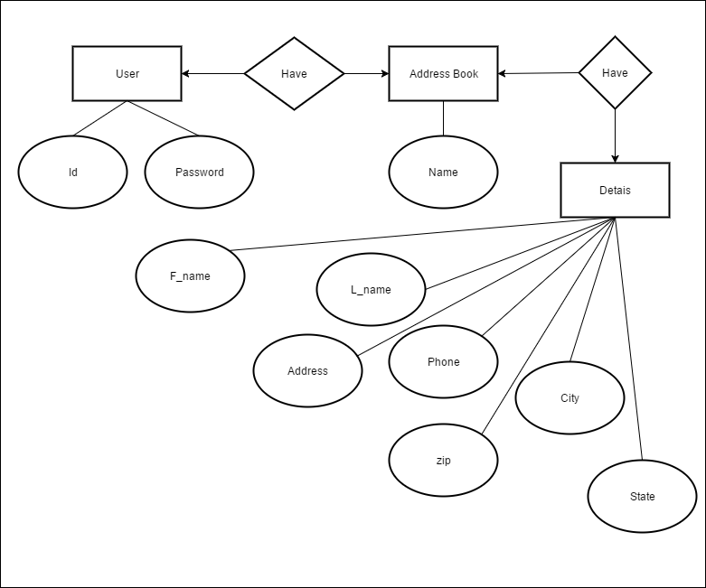

**Figure 11: ER Diagram**

# **Chapter 4**

# **Implementation:**

This project is implemented in PHP and MySQL as database.

## **4.1 References:**

* Google.com
* Wikipedia
* Draw.io

## **4.2 Project link**

https://github.com/rakib048/Address-Book-Management-System